**Active Directory Project Report**

**Introduction**

In this project, I walked through a series of essential Active Directory tasks, including:

* Adding and removing users from a domain
* Unlocking user accounts
* Creating Organizational Units (OUs) and Security Groups
* Managing Group Policy Objects (GPOs)
* Joining a domain
* Moving objects within a domain

This report details each step I took to complete these tasks.

**1. Adding Users to a Domain**

To add a new user, **Alex Adams**, to the inlanefreight.local domain, I followed these steps:

1. Opened the **Active Directory Users and Computers** snap-in.
2. Added **Alex Adams** to the **"IT" Organizational Unit (OU)**.
3. Set it so that Alex would be required to set a password upon first login.
4. A screenshot of a computer

   AI-generated content may be incorrect.
5. A screenshot of a computer

   AI-generated content may be incorrect.

**2. Removing Users from a Domain**

To remove **Paul Valencia** from the inlanefreight.local domain:

1. I right-clicked on the domain icon and selected **Find**.
2. Searched for **Paul Valencia**.
3. Right-clicked the user entry and selected **Delete**.

**3. Unlocking a User’s Account**

To unlock **Adam Masters'** account:

1. I right-clicked on the user and selected **Reset Password**.
2. Entered a new password.
3. Checked the following options:
   * **Require user to reset password at next logon**
   * **Unlock user account**

**4. Creating a New Security Group and Organizational Unit (OU)**

**Creating an OU**

1. I navigated to the **IT OU**, right-clicked, and selected **New > Organizational Unit**.
2. Named the new OU **"Security Analysts"** and clicked **OK**.

**Creating a Security Group**

1. Right-clicked on the **Security Analysts OU**.
2. Selected **New > Group**.
3. Named the group **"Security Analysts"**.
4. Set **Group Scope** as **Domain Local** and **Group Type** to **Security**.
5. Clicked **OK**.

**5. Adding a User to a Security Group**

To add **Alex Adams** to the **Security Analysts** group:

1. I right-clicked on **Alex Adams** and selected **Add to a group**.
2. Entered **"Security Analysts"** and clicked **OK**.
3. Verified that Alex was successfully added to the group.

**6. Managing Group Policy Objects (GPOs)**

**Copying and Renaming an Existing GPO**

1. I opened **Group Policy Management** from the Server Manager tools.
2. Opened **PowerShell** and ran:
3. Copy-GPO -SourceName "Logon Banner" -TargetName "Security Analysts Control"
4. Linked the new GPO to the **Security Analysts OU** with:
5. New-GPLink -Name "Security Analysts Control" -Target "ou=Security Analysts,ou=IT,OU=HQ-NYC,OU=Employees,OU=Corp,dc=INLANEFREIGHT,dc=LOCAL" -LinkEnabled Yes

**Modifying Group Policy Settings**

1. I opened **Group Policy Management Console (GPMC)** and right-clicked **Security Analysts Control**, selecting **Edit**.

1. Adjusted the following policies:
   * **Blocked Removable Storage:**
     + **Path:** *User Configuration > Policies > Administrative Templates > System > Removable Storage Access*
     + Set to **Enabled**.

* + **Allowed Security Analysts Access to Command Prompts:**
    - **Path:** *User Configuration > Policies > Administrative Templates > System*
    - Disabled **Prevent Access to the Command Prompt**.

* + **Verified Logon Banner Functionality:**
    - **Path:** *Computer Configuration > Policies > Windows Settings > Security Settings > Local Policies > Security Options*
    - Checked that the **Interactive Logon Message Text** remained unchanged.

* + **Strengthened Password Policies:**
    - **Path:** *Computer Configuration > Policies > Windows Settings > Security Settings > Account Policies > Password Policy*
    - Set **Minimum Password Length** to **12 characters**.

* + - Enabled **Require Complex Passwords**.

* + - Enabled **Enforce Password History** (set to **24**).

* + - Set **Minimum Password Age** to **5 days** and **Maximum Password Age** to **90 days**.

**7. Adding a Computer to the Domain**

To add a newly provisioned security analyst's computer to the domain:

1. I connected to the system via xfreerdp.
2. Opened **PowerShell (Administrator)** and ran:
3. Add-Computer -DomainName INLANEFREIGHT.LOCAL -Credential INLANEFREIGHT\HTB-student_adm -Restart
4. Entered the required credentials and executed the command.

**8. Moving a Computer Object to a New OU**

To move the newly provisioned computer to the **Security Analysts OU**:

1. I opened **Active Directory Users and Computers**.
2. Located the computer object.

1. Right-clicked, selected **Move**, and chose **Security Analysts OU**.

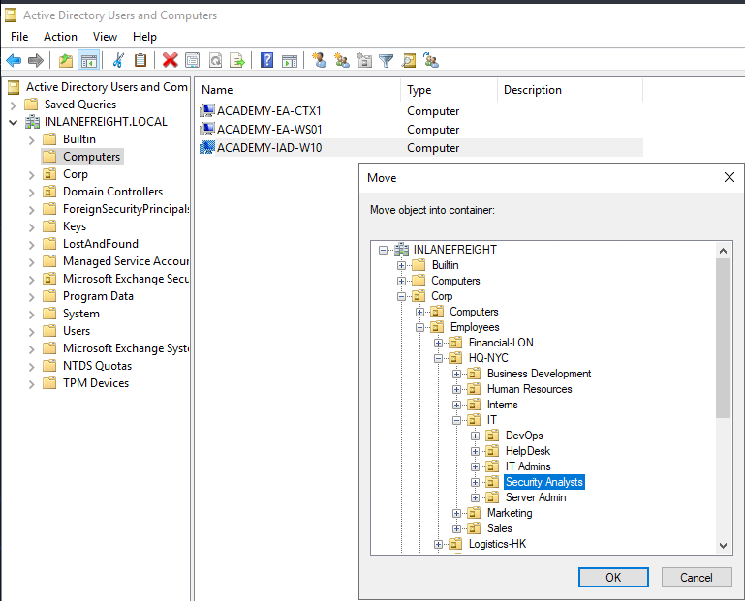

1. Confirmed that the computer object was successfully moved.

**Summary**

This project allowed me to gain hands-on experience with essential Active Directory administration tasks. From managing users and security groups to implementing Group Policy and integrating new devices, I followed structured steps to ensure a secure and efficient domain environment.

By carefully setting up OUs, enforcing strong password policies, and managing Group Policy Objects, I reinforced best practices for security and administrative efficiency. Working through these tasks provided me with a deeper understanding of how Active Directory streamlines user and device management.